**HOW TO CREATE BRAND NAME ,BRAND MAIL AND BRAND LOGO IN CANVA**

**Team id :NM2023TMID10570**

**Team members:**

1.Durgadevi.D

2.Lavanya.V

3.Mounika.R

4.Vanmathi.S

* **Brand name: Queen's Wing**
* **Category:** Clothing brand
* **Target audience:**All (Men's, Women's**)**
* **Email ID:** queen'swing@gmail.com
* **Theme of logo:** Queen's Wing is clothing brand, leggings are designed, manufactured and constructed to be durable for pillingactive wear. The materials used also have strong resistance to and fading, making them last longer.

**METHODOLOGY**

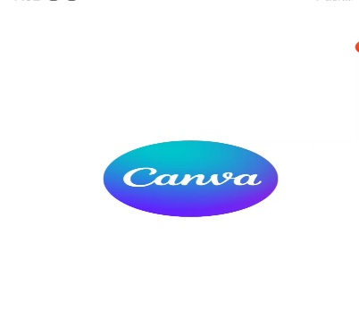Step 1: Go to canva page

Step 2:choose and template

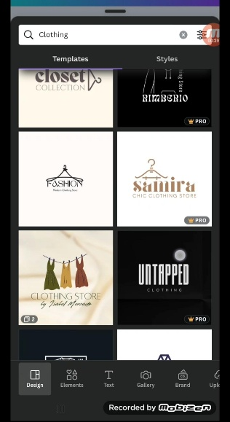

Step 3: choose the element

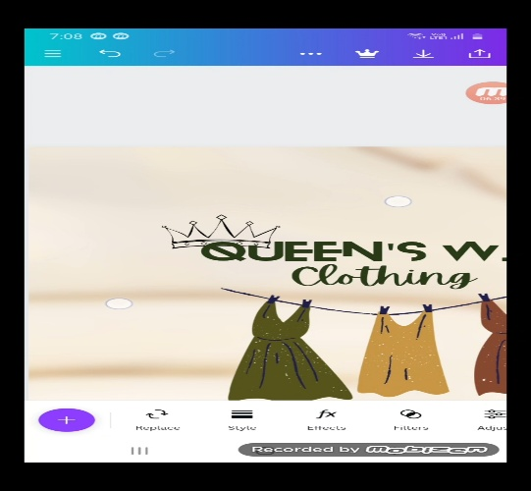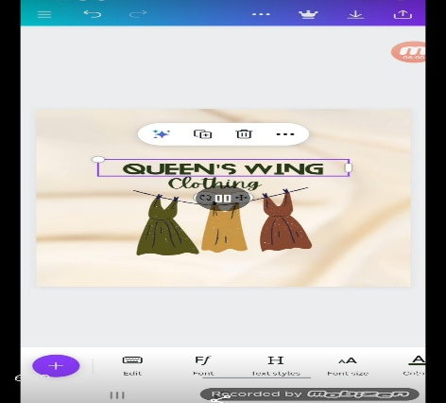Step 4: Arrange the elements as per the video requirement

Step 5: Finish editing video

**BRAND LOGO**

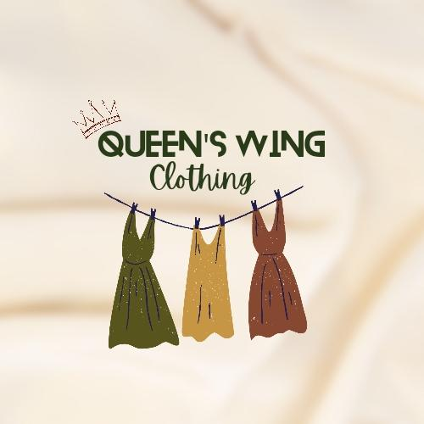**Youtube Video Link** **:https://youtu.be/AbrMSuJ_mHA?si=Bu1PBF7dqKzfcycV**